10. Inverter Parallel Guide

10.1 Parallel System Diagram
Multiple inverters can be installed together to deliver more power. When AC loads are present, all units effectively share the load. The system diagram is as follows.
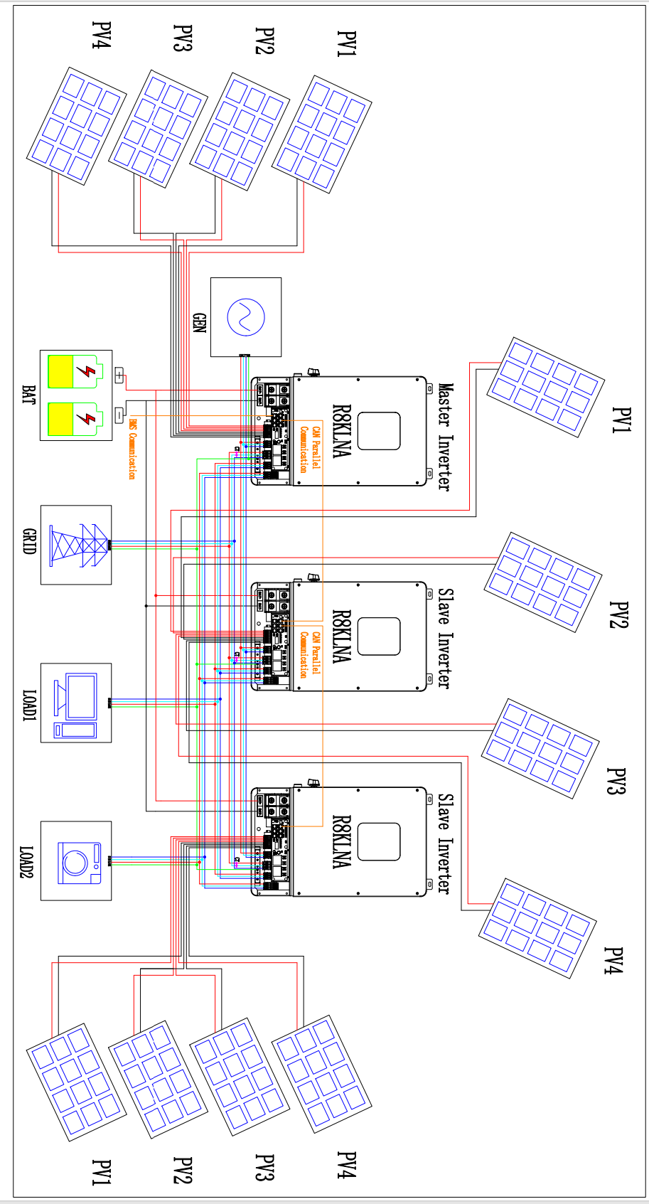

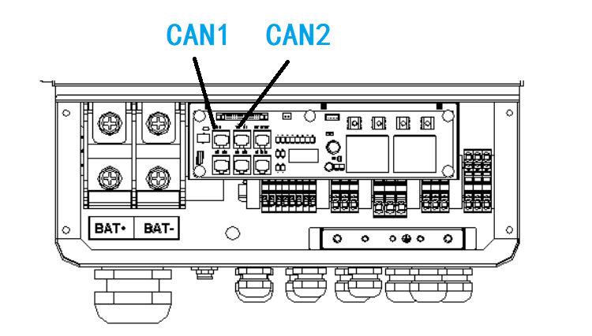
10.2 Parallel Communication Cable Connection

For parallel communication ,CAT 5 cables are needed. The units should be connected hand by hand.
When using common batteries, BMS cable needs to be connected to the master unit. The inverter shares the BMS information by inter-unit parallel communication cable.

10.3 Parallel Operation Notes
1) Make sure all the units in parallel are with the same software version.
2) Make sure all the units with the same work mode setup.
3) Please check the diagram above .The common batteries use is supported on default for maximizing the system efficiency. If independent battery is used for every inverter,the setting must be changed and every battery’s BMS cable should be connected respectively.
4) Connect the loads of the two inverters together first. It should be noted that the grid power line and the load line of the two inverters should be roughly the same length.
5) Make sure the CT Limiter sensor is installed properly. Please install CT on every unit’s incoming electrical service wires on L1 and L2(see diagram). Common CT use and programmable CT ratio function will be supported later.
6)Please make sure that if the system works in offgrid mode and hasn’t been powered on before, the slaver unit will wait the master unit to work normally first.

10.4 Parallel System Setting
The parallel setting page can be visited in the following steps in the screen:
USER->1. SETUP->PASSORD CHECK->15.parallel

10.4.0 Setting
Interface | Description
Parallel. 1.NUM. 2.MASTER/SLAVER 3.ADDRESS 4.PHASE A/B/C 5.BAT INDEP 6.PARALLEL EN | This interface shows parallel setting.  - Total numbers of the inverters.  - In a parallel system,the master unit broadcasts the bms and other information to the slavers. Make sure only one unit is configued as master.  - Local unit address(1-8).  - Local phase of unit for three-phase installation. (reserved function)  - Common battery or independent battery.  - Enable/Disable the parallel function.

10.4.1 Parallel Error information
Interface | Description
ERROR NO.  11:parallel fail | A parallell warning may occur because of the following reasons:  - Wrong setup of the parallel num.  - Wrong inter-unit parallel communication cable.  - Wrong setup of the unit address.

